

# QBraille XL

## Type of device: Tablet

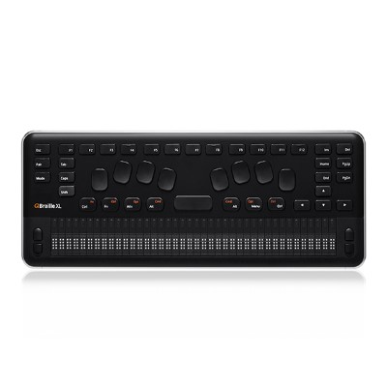

Operating System : Microsoft

Version Number : Windows CE 6.0

Year of Release : 2019

Average Price : $3195 as of 28 09 2021

Internet Access : Wi-Fi Only

## Accessibility Features:

### Cognitive

* Copy and Paste
* Simple Reminders

Voice Notes

### Hearing Impairment and Deaf

* Bluetooth or Wi-Fi
* Closed Captioning

Vibrating Alerts - Adjustable

### Vision

* Battery Alert - Audible
* Bluetooth or Wi-Fi
* Braille Display Support
* Dictation / Speech-to-Text
* Key Press - Vibration or Click
* Personalised Shortcuts
* Power Cue
* Voice Control /Personal Assistant

Voiced Menus

### Speech

* Bluetooth or Wi-Fi

Messaging Options - Email

### Physical

* Bluetooth or Wi-Fi
* Dictation / Speech-to-Text
* Flat Back for Table Top Operation
* Guarded/Recessed Keys
* Physical Dialling Keys
* Speaker-phone option

Voice Control / Personal Assistant

## How and where to get it from?

You can buy this phone from [HIMS](https://hims-inc.com/product/qbraille-xl/), and other retailers.

## More information is available on:

[QBraille XL Webpage](https://hims-inc.com/product/qbraille-xl/)

[QBraille XL User Manual (Word Document Download)](https://hims-support.com/download/qbraille-xl-user-manual/?wpdmdl=768&refresh=60d278f9bd2941624406265)

[HIMS Support Webpage](https://hims-support.com/)